CHAPTER – III
BUILDING STRUCTURES

FOUNDATIONS
Every structure consists of two parts. (1) Foundation and (2) Super structure. The lowest artificially prepared parts of the structure which are in direct contact with the ground and which transmit the loads of the structure to the ground are known as Foundation or Substructure. The solid ground on which the foundation rest is called the “foundation bed” or foundation soil and it ultimately bears the load and interacts with the foundations of buildings.

Objects of foundations:

Foundations are provided for the following purposes
- To distribute the total load coming on the structure on large area.
- To support the structure
- To give enough stability to the structures against various distributing forces such as wind, rain etc.
- To prepare a level surface for concreting and masonry work.

Types of foundations:

Depending upon their nature and depth, foundations have been categorized as follows
a)Open foundations or shallow foundations

b)Deep foundations

Open foundations or shallow foundations: This is most common type of foundation and can be laid using open excavation by allowing natural slopes on all sides. This type of foundation is practicable for a depth of about 5m and is normally convenient above the water table. The base of the structure is enlarged or spread to provide individual support. Since the spread foundations are constructed in open excavations, therefore they are termed as open foundations. This type of foundation is provided for structure of moderate height built on sufficiently firm dry ground. The various types of spread footings are:
1. Wall footing
2. Isolated footing
3. Combined footing
4. Inverted arch footing
5.Continuous footing
6.Cantilever footing
7.Grillage footing
Wall Footing: These footings can be either simple or stepped. The base course of these footings can be concrete or entirely of one material simple footing are used for light structures. They have only one projection beyond the width of the wall. The base width of the concrete base course should be equal to twice the width of wall.
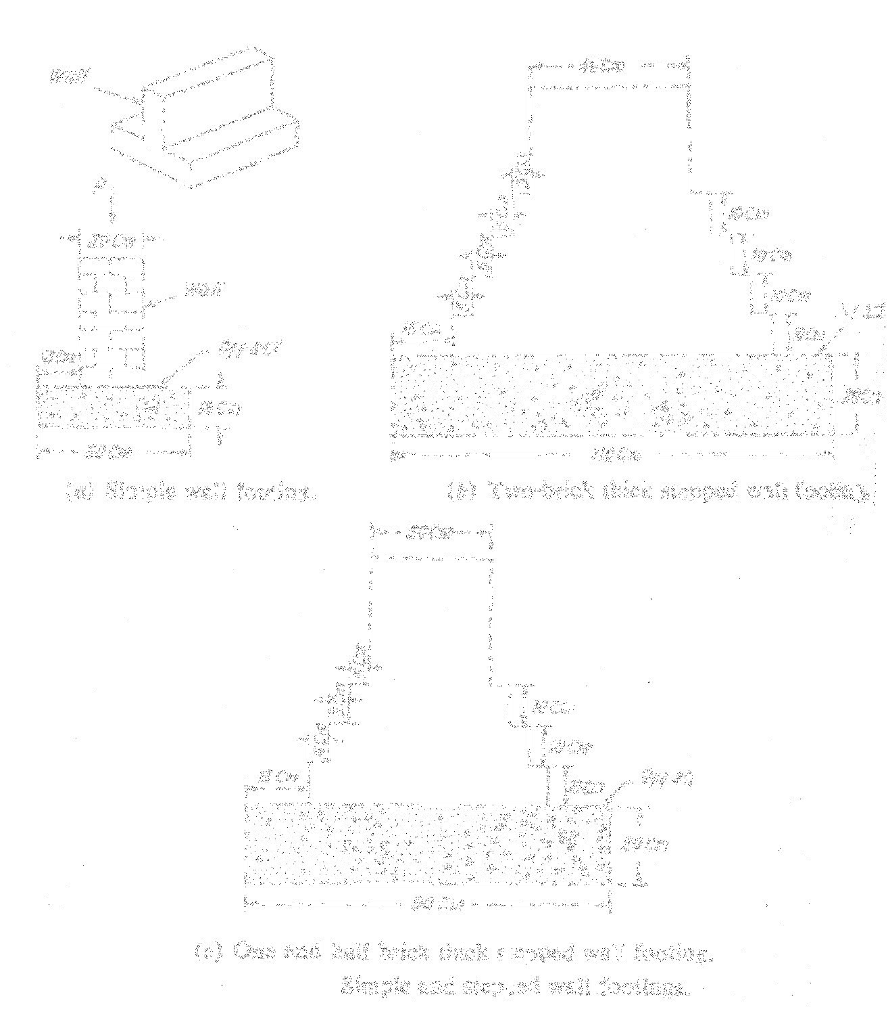

Fig 10.3

The depth of concrete bed is atleast twice the projection as shown in fig 10.3. The depth of concrete bed is calculated by the depth of footing is generally limited to 0.9m the width of footing should be calculated by divided the total load in kg/m run by the allowable bearing capacity of soil in kg/m2.
Isolated Footings: These are used to support individed columns. They can be of stepped type or have projections in the concrete base. In case of heavy loaded columns steel reinforcement is provided in both directions in concrete with 15cm offsets as shown in the fig10.4.
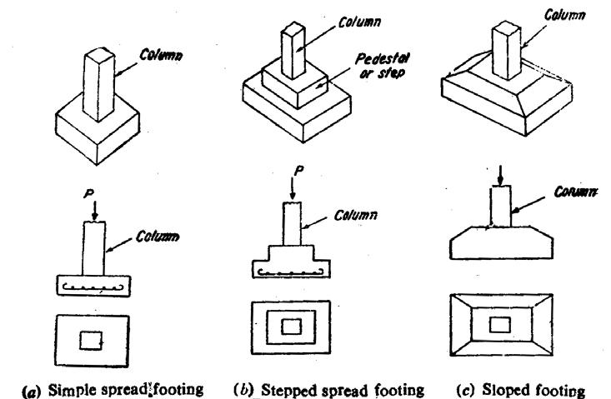

Fig 10.4 Types of Isolated Footings
Combined Footing: A combined footing supports two or more columns in a row A Combined footing may be rectangular or trapezoidal constructed with reinforced concrete. The location of centre of gravity of column loads and centroid of the footing should coincide. The combined footing is as shown in fig10.5.
Inverted Arch Footing: This type of construction is used on soft soils to reduce the depth of foundation loads above an opening are transmitted from supporting walls through inverted arches to the soil. In this type the end columns must be stable enough to resist the outward pressure caused by arch actions. The inverted arch footing is as shown in fig10.6.

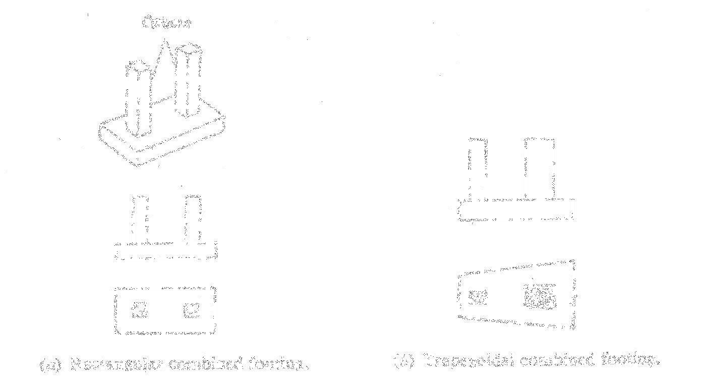

Fig 10.5 Combined Footings
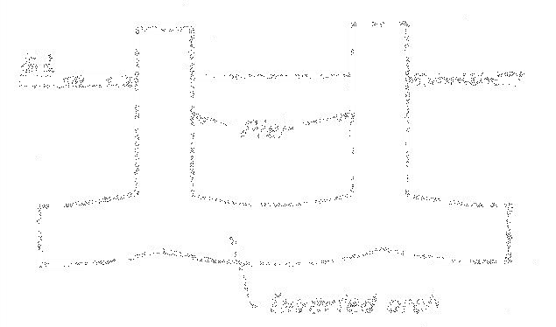

Fig 10.6 Inverted Footing
Continuous Footing: In this type of footing a single continuous R.C slab is produced as foundation of two or three or more columns in a row. This type of footing is suitable at locations liable to earthquake activities. This also prevents differential settlement in the structure. In order to have better stability a deeper beam is constructed in between the columns as shown in fig10.7.
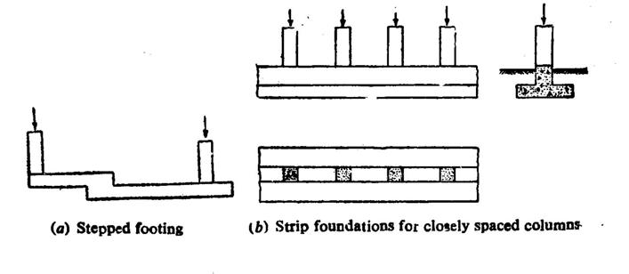

Fig 10.7 Continuous Footing

Strap or cantilever footing: Strap footing consists of two or more individual footings connected by a beam called strap or cantilever footing or pump handle foundation. This type of foundation may be used where the distance between the columns is so great that combined trapezoidal footing becomes quite narrow with high bending moments strap or cantiliver footing is as shown in fig 10.8.
Grillage footing : This type of footing is used to transmit heavy loads from steel columns to foundation soils having low bearing power. This type of foundation avoids deep excavation and provides necessary area at the base to reduce the intensity of pressure of the foundation soil is not stiff and there is a plenty of water with spring, the sides are protected by sharing. The grillage footing is a s shown in fig 10.9.
Raft Foundation: A raft or mat is a combined footing that covers the entire area beneath a structure and supports all the columns. When the allowable soil pressure is low or the structure loads are heavy the use of spread footings would cover more than one half of the area and it may be prove more economical to use raft foundation.
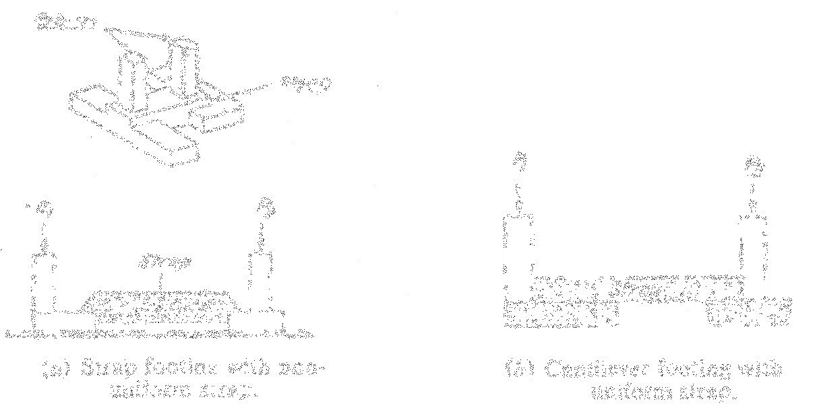

Fig 10.8 Strap or cantilever footing

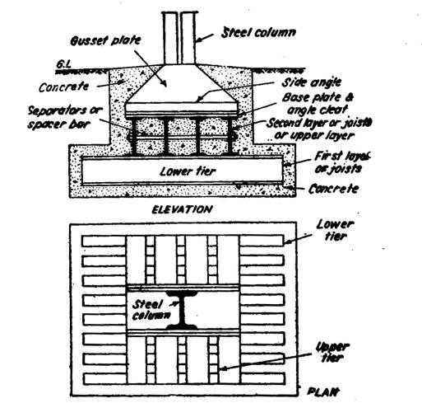

Fig 10.9 Grillage Footing

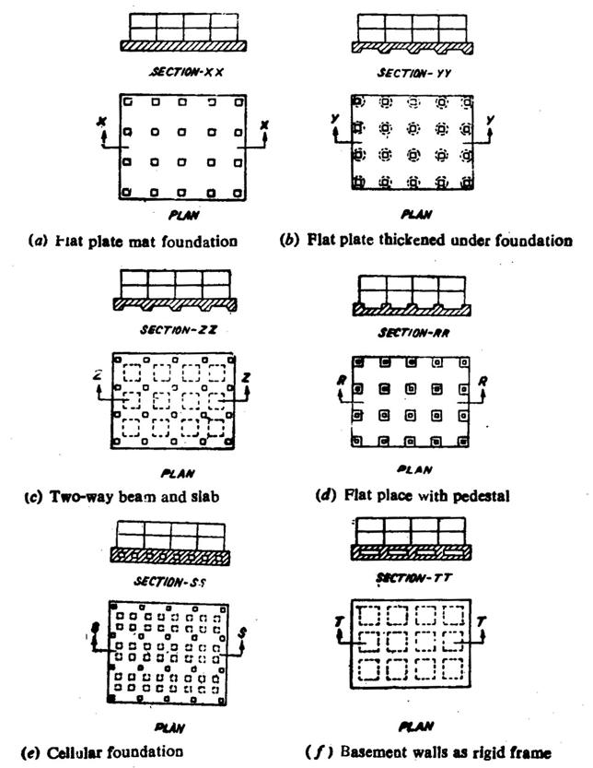
There are also used where the soil mass contains compressible lenses so that the differential settlement would be difficult to control usually when the hard soil is not available within 1.5 to 2.5m, a raft foundation is adopted. The raft is composed of reinforced. Concrete beam with relatively thin slab underneath fig 10.10 shows different types of raft.

Fig 10.10 Different types of Raft Foundations

Deep foundations:

These foundations carry loads from a structure through weak compressible soil or fills onto the stronger and less compressible soils or rocks at depth. These foundations are in general used as basements, buoyancy rofts, eaissions, cylinders, shaft and piles.
Basements: There are constructed in place in an open excavation. They are hallow slab structure designed to provide working or storage space below ground level. The structural design is governed by their functional requirements.

Buoyancy rafts: They are hallow substructures designed to provide a buoyant substructure beneath with the net loading on the soil reduce to the desired low intensity.

Coissions: They are hallow substructures designed to be constructed on or near the surface and then sunk as single units to their required level.

Cylinders: They are small single cell coissions

Shaft foundations: They are constructed within deep excavation supported by lining constructed in place subsequently filled with concrete.

Pile foundations: Pile foundation is a construction for the foundation supported on piles. A pile is an element of construction composed of timber, concrete, or steel or a combination of them. Pile foundation may be defined as a column support type of a foundation, which may be cast in-situ or Pre-cast. This type of construction is adopted when the loose soil extends to a great depth. The load of the structure is transmitted by the piles to hard stratum below or it is resisted by the friction developed on the sides of pipes.

Classification based on the function

Bearing piles- Penetrate through soft soil and their bottom rest on a hard stratum
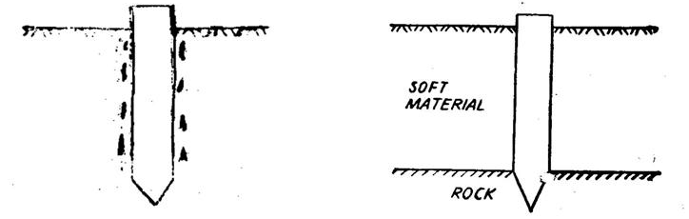
Friction piles- The frictional resistance is equal to load coming on the piles as shown in the fig 10.1

Fig 10.11 Friction file & Bearing Pile
Screw piles-Used for gravely ground sand, mixed gravel ground etc as shown in fig 10.12.
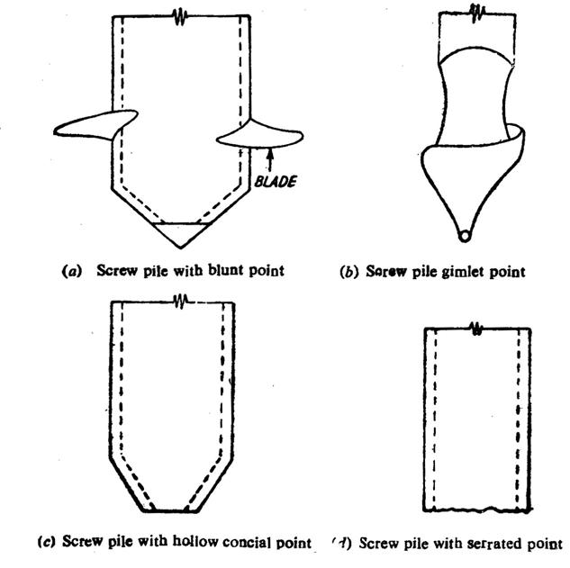

Fig 10.12 Different types of screw piles

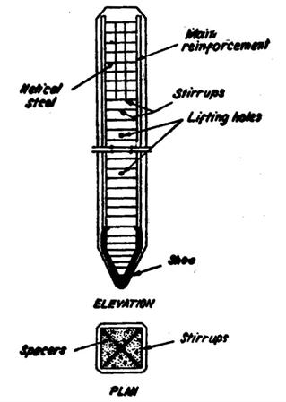
Uplift piles- when the structure subjected to uplift pressure.
Butter pile – To resist large horizontal or inclined forces

Sheet pile-used as bulk heads or a impervious cutoff

Classification based on materials and composition

a) Cement concrete piles-Posses excellent compressive
strength
1) Precast
2) Cast-in-site
a) Under reamed piles
b) Bored compaction piles as shown in fig 10.13.

Fig 10.13. Pre-cast concrete Pile

Timber piles-Small bearing capacity, not suitable for hard soil and economical
Steel piles-With stand impact stresses and resist lateral forces
Sand piles-Not suitable for loose or wet soils or where is a danger of scour. Easy to construct and irrespective of water table.
Composite piles- combination of two different materials are used to form composite file and suitable where the upper part of pile to project above the water table. Economical and easy to construct as shown in fig 10.14
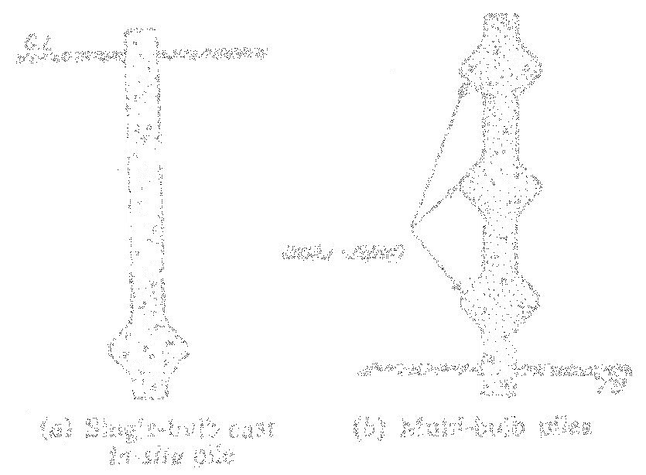
Fig 10.14 Under-reamed Piles
Requirements of a good foundation:

Following are the three basic requirements to be fulfilled by a foundation to be satisfactory

Location : The foundation should be located that it is able to resist any unexpected future influence which may adversely affect its performance. This aspect requires careful engineering judgement.
Stability: The foundation structure should be stable or safe against any possible failure
Settlement: The foundation structure should not settle or deflect to such an extent so as to impair its usefulness.
MASONRY

Masonry is defined as the art of construction in which building units, such as clay bricks, sand-lime, bricks, stones, Pre-cast hallow concrete blocks, concrete slabs, glass bricks, combination of some of these building units etc are arranged systematically and bonded together to form a homogeneous mass in such a manner that they can with stand point to other loads and transmit then through the mass without fail or disintegration.
Masonry can be classified into the following categories.

a)Stone masonry

b)Brick masonry

c)Hallow block concrete masonry

d)Reinforced masonry

e)Composite masonry
These can be further sub-divided into varies types depending upon workmanship and type of materials used.
Definitions of terms:

Course: A course is a horizontal layer of bricks stones
Bed: the surface of a stone perpendicular to the line of pressure of (lower surface of bricks or stones in each course)
Back: The inner surface of wall not exposed is called back. The material forming back is known as backing
Face: The exterior of the wall exposed to weather is known as face. The material used in the facing of wall is known as facing’

Hearting: It is the interior portion of a wall between facing and backing

Head: It is a brick or stone, which lies with its greatest length at right angles to the face of the work.

Stretcher: It is a brick or a stone which lies with its congest side parallel to the face of the work

Bond: The method of arranging bricks so that the individual units are tied together

Spalls: The chips of stones used for filling the interstics in stone masonry

Quoins: The stones used for the corners of walls of structure

Bat: It is a portion of a brick cut across the width.

Closer: It is the portion of a brickcut in such a manner that its one long face remains uncut

Queen closer: it is the portion of a brick obtained by cutting a brick length-wise into two portions

King closer: It is the portion of brick obtained by cutting off the triangular piece between the centre of one end and the centre of one side.

Bevelled closer: It is the portion of a brick in which the whole length of the brick is bevelled for maintaining half width at one end and full width at the other
Frog: It is an indentation or depression on the top face of a brick made with the object of forming a key for the mortar.

Sill: It is a horizontal stone, concrete or wood, employed for the purpose of shedding off rain water from the face of wall immediately below the window opening

Corbel: It is the extension of one or more course of stone or brick from the face of a wall to serve as a support for wall plates

Templates: Pieces of stones placed under the end of a beam to distribute load over a greaterarea.

Coping: It is the course placed upon the exposed top of an external wall to prevent the seepage of water
Buttress: It is a sloping or stepped masonry projection from a tall wall intended to strengthen the wall against the thrust of a roof as shown in fig 11.1
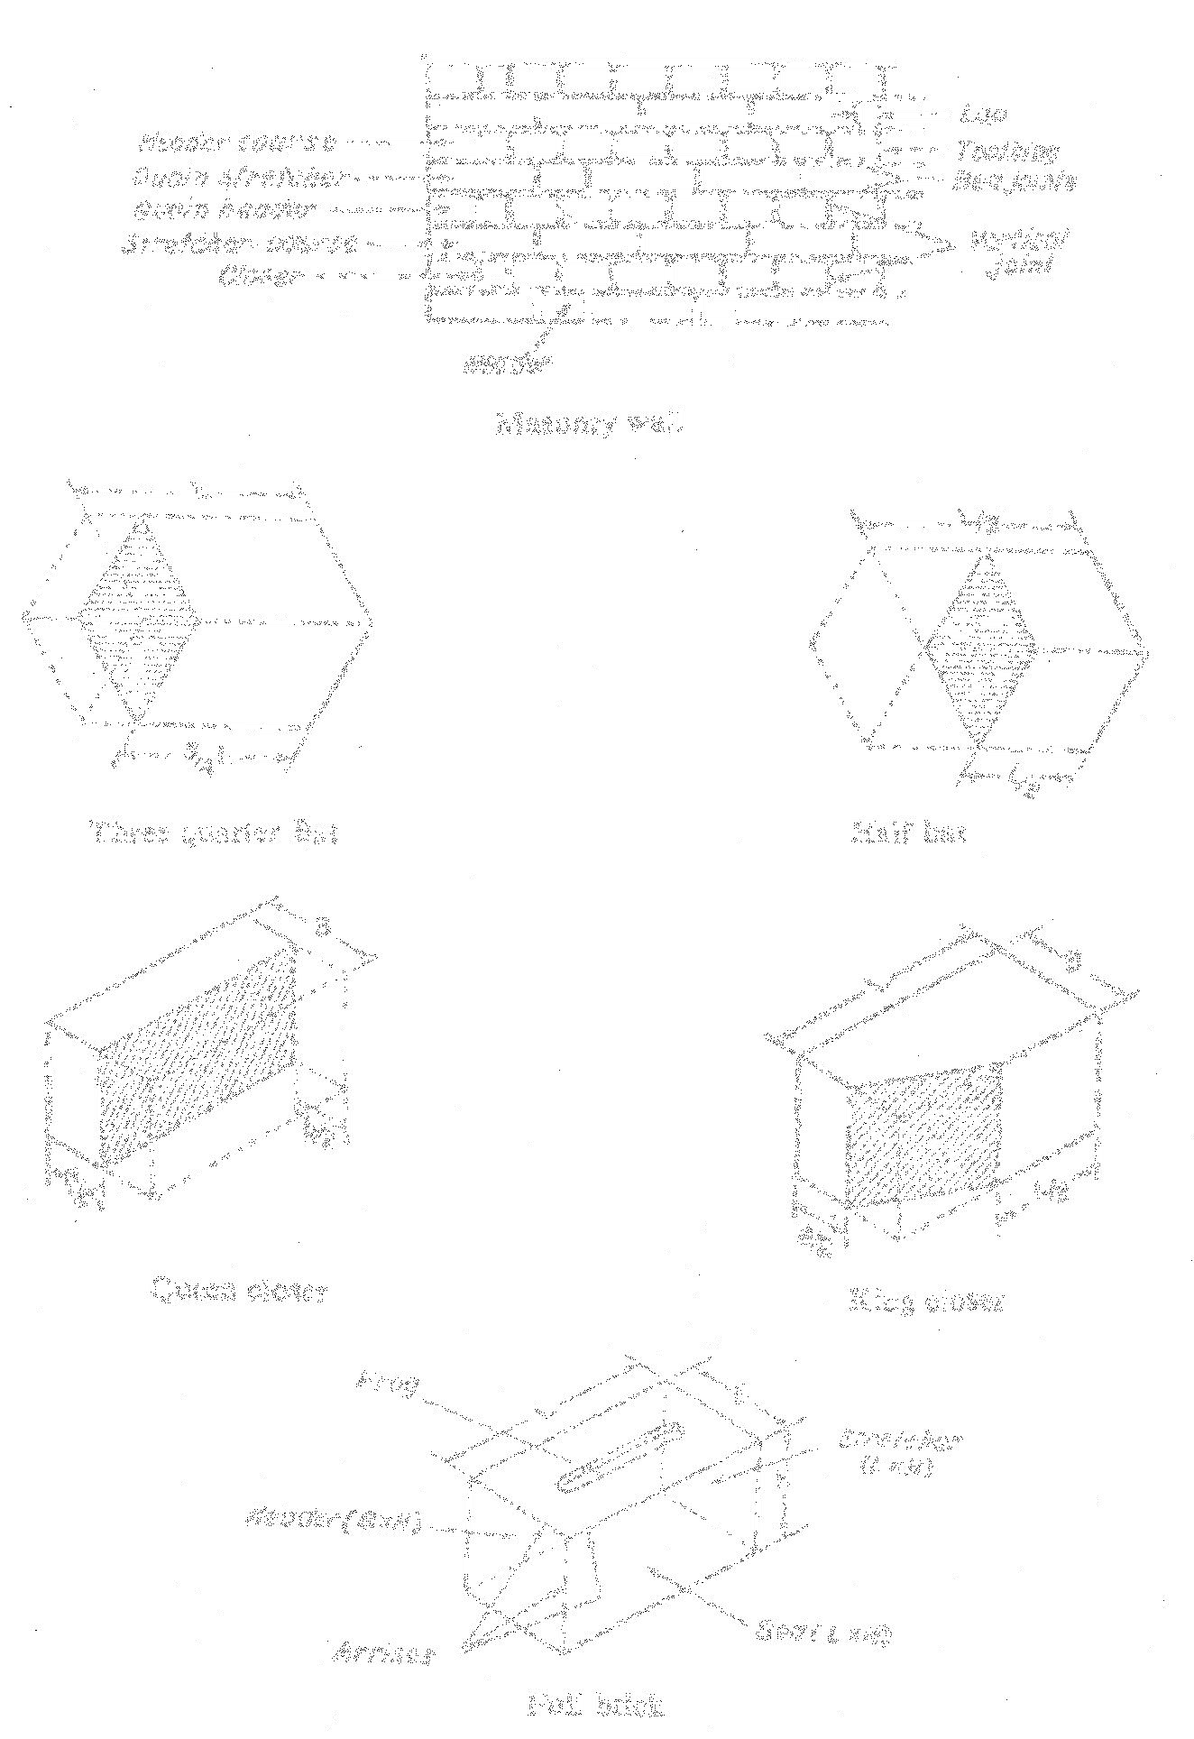

Fig 11.1 Definitions of terms

1.Stone masonry: The construction of stones bonded together with mortar is termed as stone masonry where the stones are available in a abundance in nature, on cutting and dressing to the proper shape, they provide an economical material for the construction of various building components such as walls, columns, footings, arches, lintels, beams etc.
Uses of stone masonry:

Stone masonry construction is used in

Building foundations, dams, monumental structures
Building walls, piers, columns, pillars, light houses and architectural works.
Arches, domes, lintels and beams

Roofs, flems, paving jobs

Railway, bullest, black boards and electrical switch boards

2.Types of Stone Masonry:

Based on the arrangement of the stone in the construction and degree of refinement in the surface finish, the stone masonry can be classified broadly in the following two categories
- Rubble masonry

- Ashlar masonry

General principles in the stone masonry construction
1. The stones to be used for stone masonry should be hard, tough and durable.
2. The pressure acting on stones should be vertical

3. The stones should be perfectly dressed as per the requirements

4. The heads and bond stones should not be of a dumb bell shape.

5. In order to obtain uniform distribution of load, under the ends of griders, roof trusses etc large flat stones should be used
6. The beds of the stones and plan of the course should be at right angles to the slope in the case of sloping retaining wall
7. Wood boxing should be filled into walls having fine dressed stone work to protect it during further construction
8. The mortar to be used should be good quality and in the specified faces.
9.The instruction work of stone masonry should be raised uniformly.

10.The plumb bob should be used to check the vertically of erected wall
11.The stone masonry section should always be designed to take compression and not the tensile stresses
12. The masonry work should be properly cured after the completion of work for a period of 2 to 3 weeks
13. As per as possible broken stones or small stones chips should not used
14. Double scaffolding should be used for working at higher level

15. The masonry hearting should be properly packed with mortar and chips if necessary to avoid hallows
16.The properly wetted stones should be used to avoid mortar moisture being sucked

Rubble masonry: In this category, the stones used are either undressed or roughly dressed having wider joints. This can be further subdivided as uncoursed, coursed, random, dry, polygonal and bint.
Uncoursed rubble masonry: This is the cheapest, roughest and poorest form of stone masonry. The stones used in this type of masonry very much vary in their shape and size and are directly obtained from quarry. Uncoursed rubble masonry can be divided into the following.
a) Uncoursed random rubble
b) Uncoursed squared rubble

a)Uncoursed random rubble masonry: The weak corners and edges are removed with mason’s hammer. Generally, bigger stone blocks are employed at quoins and jambs to increase the strength of masonry.

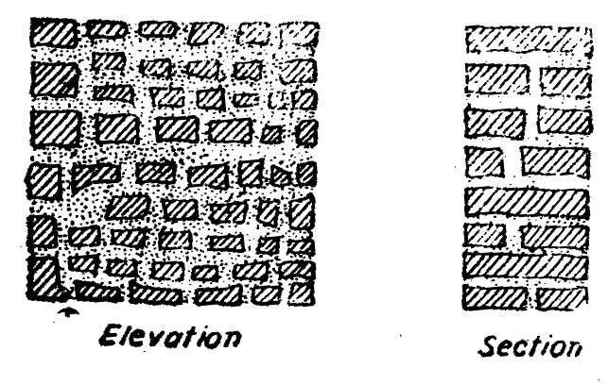

Fig 11.3 Uncoursed random rubble masonry

b)Uncoursed squared rubble: In this type the stone blocks are made roughly square with hammer. Generally the facing stones are given hammer-dressed finish. Large stones are used as quoins. As far as possible the use of chips in bedding is avoided as shown in 11.4.
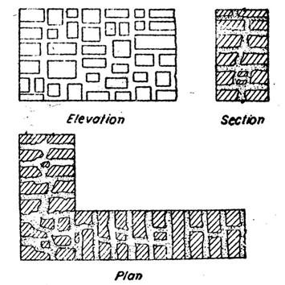

Fig 11.4 Uncoursed squared rubble masonry

Coursed random rubble: This type of masonry is commonly used in the construction of low height walls of public buildings, residential buildings, abutment and piers of ordinary bridges. The stones of 5 to 20cm size are used in each course as shown in fig 11.5.
Fig 11.5 Coursed Random Rubble
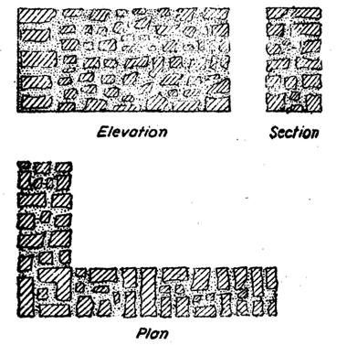

(iii)Coursed squared rubble: This type of masonry is made up of hammer squared stones facing with bonded backing of uncoursed random rubble masonry. The stones employed in each course are of equal height. The backing and facing construction, should be carried simultaneously. In order to avoid thick mortar joints, small chips may be used as shown in the fig 11.6.
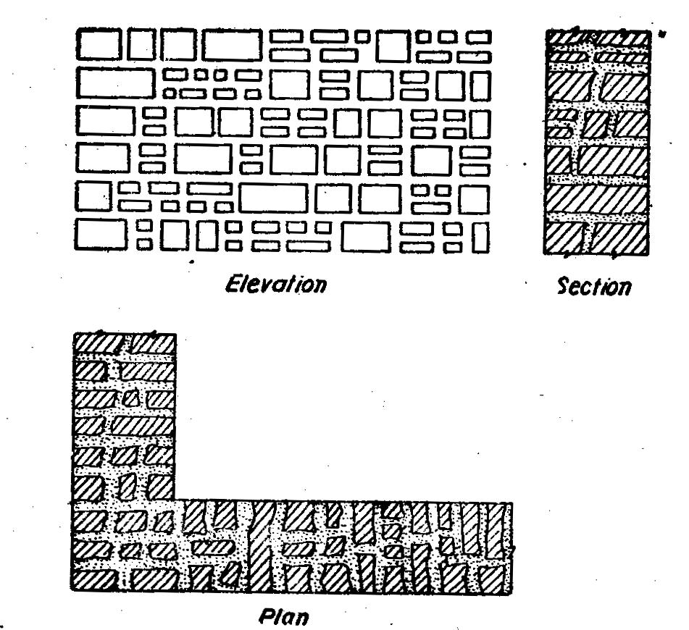

Fig 11.6 Coursed Squared Rubble Masonry

Built to regular course: In this type of stone masonry the uniform height stones are used in horizontal layers not less than 13cm in height. Generally, the stone beds are hammered or chisel dressed to a depth of atleast 10cm from the face. The stones are arranged in such a manner so that the vertical joints of two consecutive curse donot coincide with each other as shown in fig 11.7.
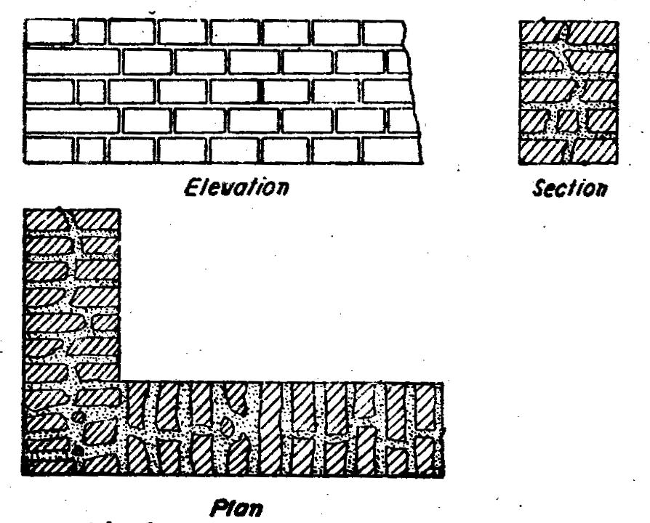

Fig 11.7 Built to regular courses

Polygonal rubble masonry: In this type of masonry the stones are roughly dressed to an irregular polygonal shape. The stones should be so arranged as to avoid long vertical joints in face work and to break joints as much as possible. Small stone chips should not be used to support the stones on the facing as shown in fig 11.8.
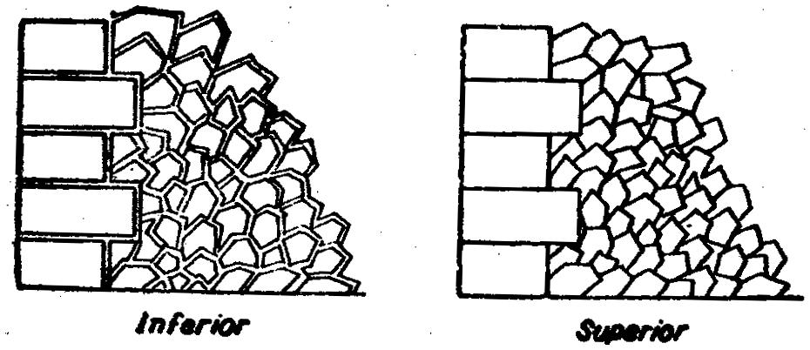

Fig. 11.8 Polygonal rubble masonry

Plint rubble masonry: This type of masonry is used in the areas where the flint is available in plenty. The flint stones varying in thickness from 8 to 15cm and in length from 15 to 30cm are arranged in the facing in the form of coursed or uncoursed masonry as shown in fig 11.9.

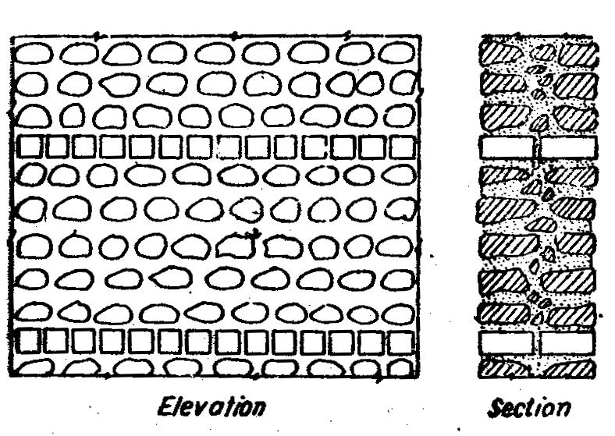

Fig 11.9 Plint Rubble Masonry

Dry rubble masonry: This type of masonry is used in the construction of retaining walls pitching earthen dams and canal slopes in the form of random rubble masonry without any mortar. The hallow spaces left around stones should be tightly packed with smaller stone pieces as shown in fig 11.10.
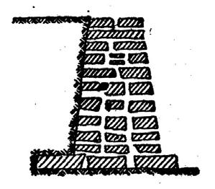

Fig 11.10 Dry Rubble Masonry

Ashlar Masonry: This type of masonry is built from accurately dressed stones with uniform and fine joints of about 3mm thickness by arranging the stone blocks in various patterns. The backing of ashlar masonry walls may be built of ashlar masonry or rubble masonry. The size of stones blocks should be in proportion to wall thickness. The various types of masonry can be classified under the following categories as shown in fig 11.11 to fig 11.13 .
1. Ashlar fine
2.Ashlar rough
3.Ashlar rock or quarry faced
4.Ashlar facing
5.Ashlar chamfered
6.Ashlar block in course
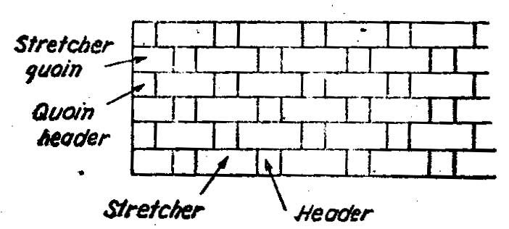

Fig 11.11 Ashlar Fine Masonry
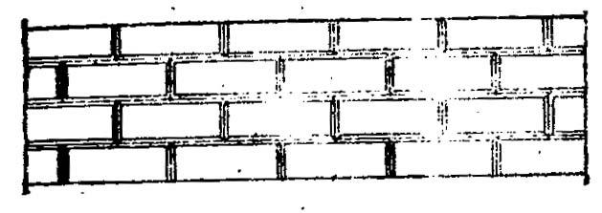

Fig 11.12 Ashlar chamfered Masonry
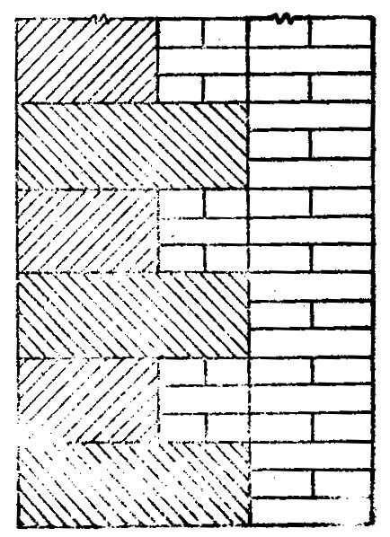

Fig 11.13 Ashlar Facing

3.Brick masonry:

Brick masonry is a unified mass obtained by systematic arrangement of laying bricks and bonding together with mortar. Brick is a building unit of hard inorganic clay material of size which can be conviently handled. The brick masonry is used in foundations, walls, columns, buttresses, retaining structures window sells, jambs, corbels, copings ornamental brickwork, circular brickwork, fire places, flumes, tall chimneys, cavity walls, thresholds, culverts, steps, floors, arches etc. The strength of brick masonry works depends upon the quality of bricks and type of mortar used.

Generally mortars are following types used for brick masonry

1.Mud mortar

2.Cement mortar

3.Cement lime mortar

4.Lime surkhe mortar

General principles in brick masonry construction:

1.A good brick masonry should utilize bricks, which are sound, hard, well burnt and tough with uniform colour, shape and size.

2.The bricks should be compact, homogenious, free form holes, cracks, flaws, air-bubbles and stone lumps and soaked in water for atleast two hours before use

3.In the brickwork, the bricks should be laid on their beds with the frogs pointing upwards
4.The brick courses should be laid truly horizontal and should have truly vertical joints
5.As far as possible the use of brick – bats should be discouraged

6.As far as possible the brick wall should be raised uniformly less than 1.5m in day with proper bond.

7.When the mortar is green the face joints should be racked to a depth of 12 to 19mm in order to have a proper key for plastering or pointing.

8.In order to ensure continuous bond between the old and the new, the wall should be stopped with a toothed end.

9.Finished brickwork should be cured for a period of 2 to 3 weeks for lime mortar and 1 to 2 weeks for cement mortar

10.In order to carryout the brickwork at higher level, a single scaffolding is used.

Types of brick bonds:

Bonding is a process of arranging bricks and mortars to tie them together in a mass of brickwork. It should have a minimum of vertical joints in any part of the work.

Characteristics of brick bond or rules for bonding:

1. The brick masonry should have bricks of uniform shape and size

2.For satisfactory bondage the lap should be one-fourth of the brick along the length of the wall and half brick across thickness of the wall

3.The brick bats use should be discouraged

4.The vertical joints in the alternate courses should coincides with the centre line of the stretcher

5.The alternate courses the centre line of header should coincide with the centre line of stretcher, in course below or above it.

6.The stretcher should be used only in the facing while hearting should be done in the headers only
Classifications of bonds: The bonds can be classified as follows:

1.Stretcher bond

2.Header bond

3.English bond

4.Double Flemish bond

5.Single Flemish bond

6.Garden wall bond

7.Facing bond

8.Dutch bond

9.Raking bond

10.Zigzag bond

11.English cross bond

Stretcher bond: In this type of bond all the bricks are laid with their lengths in the direction of the wall. This pattern is used only for wall having thickness of 9cm only as shown in fig 11.14.


Fig 11.14 Stretcher Bond

Header bond: In this type of bond all the bricks are laid with their ends towards the face of the wall. This arrangement is suitable for one brickwall of curved wall and footings for better load distribution as shown in fig 11.15.


Fig 11.15 Header Bond

English bond: In this type of bond alternate course of headers and stretchers are laid. It is necessary to place queen closer in the heading course for breaking the joints vertically. The different english bonds are as shown in fig 11.16 and 11.17.

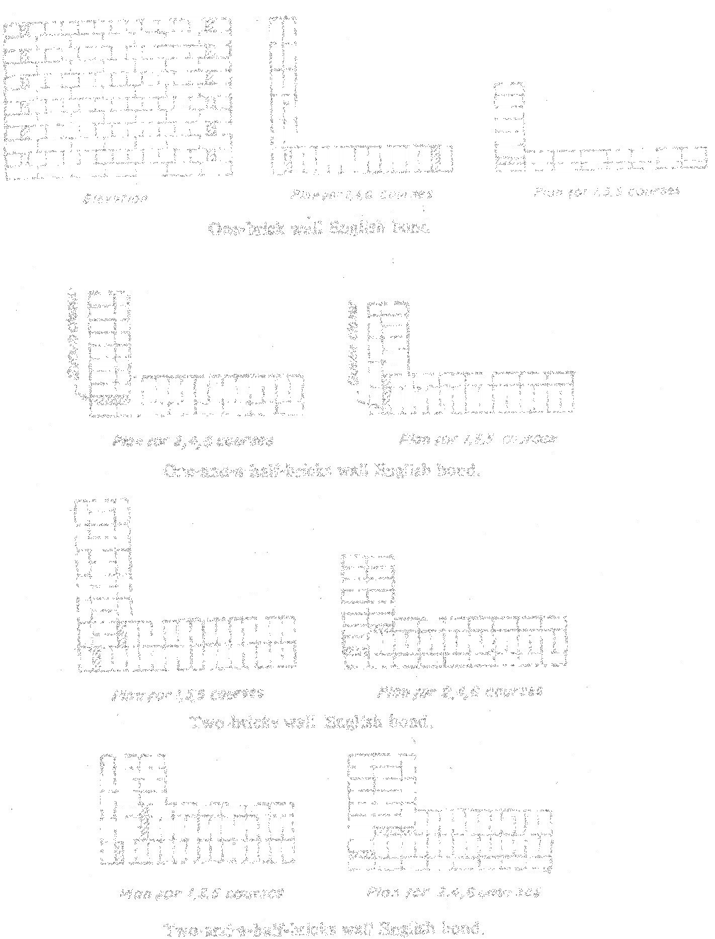

Fig 11.16 English Bond

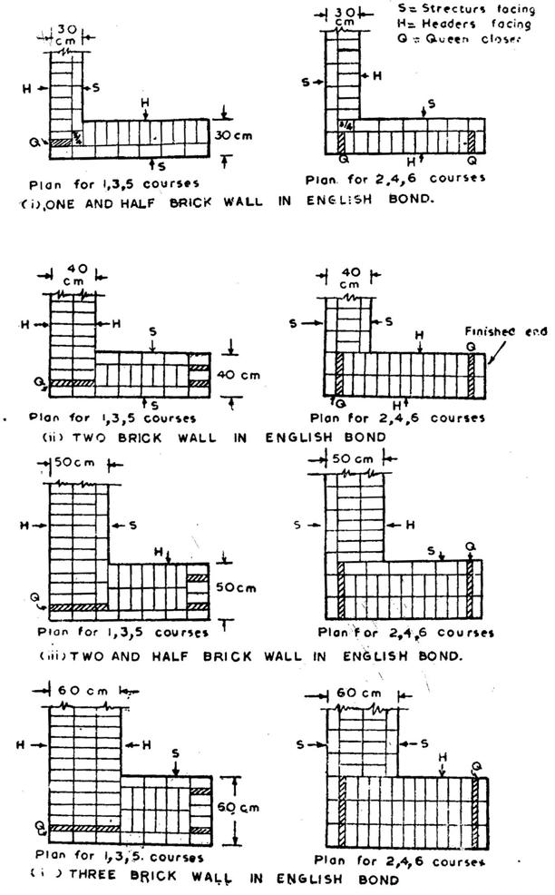

Fig 11.17 Alternate arrangements for various

wall thicknessess in English Bond

Double Flemish bond: In this type, alternate heads and stretchers are laid in each course. The facing and backing are of the same appearance brickbats and queen closers are used. The double Flemish bond is as shown in fig 11.18.

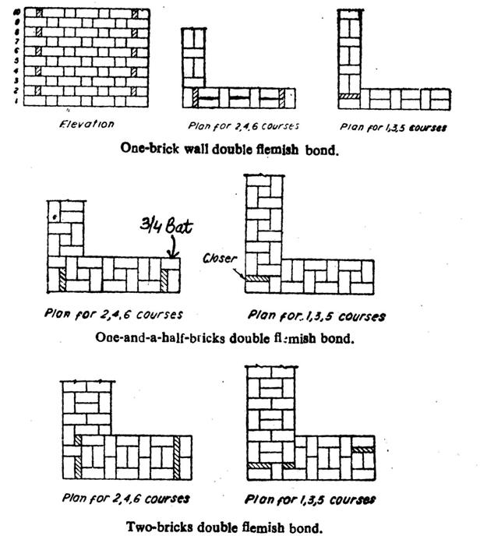

Fig 11.18 Double Flemish Bond
Single Flemish bond: This type of bond is comprised of double Flemish bond facing and English bond backing in each course.
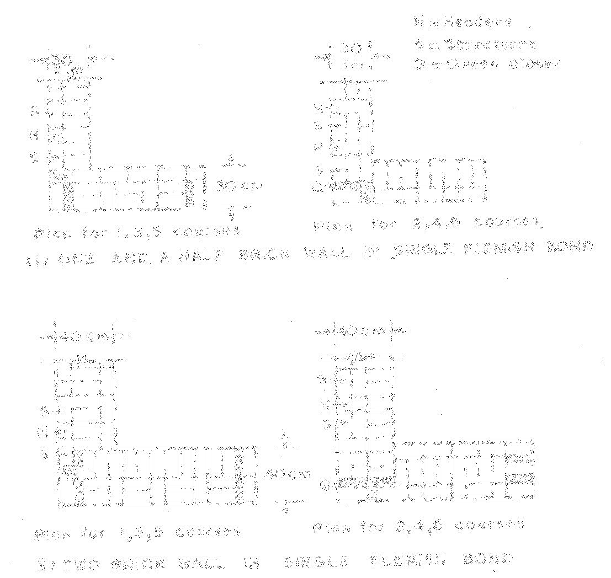
Fig 11.19 Single Flemish Bond

This type of construction partially possesses the strength of English bond, and appearance of Flemish bond. As this type of bond requires minimum thickness of 1 ½ bricks so it cannot be used for walls having thickness less than 1½ bricks. The fig 11.19 shows the single Flemish bond.

Garden wall bond: This type of bond is employed for the construction of garden walls, compound walls, boundary walls etc. This wall bond can be both English as well as Flemish as shown in the fig 11.20 & 11.21

Fig 11.20 English Garden Wall Bond


Fig 11.21 Flemish Garden Wall Bond

Facing bond: In this type of bond bricks of different thickness are used in the facing and backing of the wall. In this case, a header course is placed after several stretcher courses. In this type of bond, the distance between the successive heading courses is equal to common multiple of thickness of backing and facing bricks.
Dutch bond: This is the modified form of English bond. The corners of the wall provided with dutch bond are quite strong. The alternate courses in this type of bond are headers and stretchers. In stretcher course ¾ bat is used as quoin. A header is placed next to the ¾ bat in every alternate stretcher course as shown in the fig 11.22.

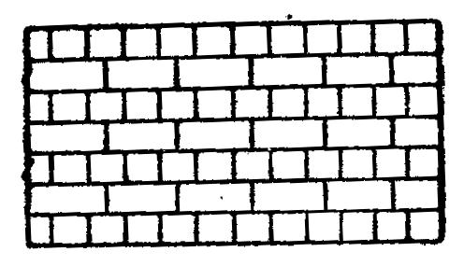

Fig 11.22 Dutch Bond

Raking bond: In this type of bond alternate courses are placed in different directions to get maximum strength in the wall. The racking courses are laid to certain interval along the height of the wall in very thick wall having number of headers more than the no.
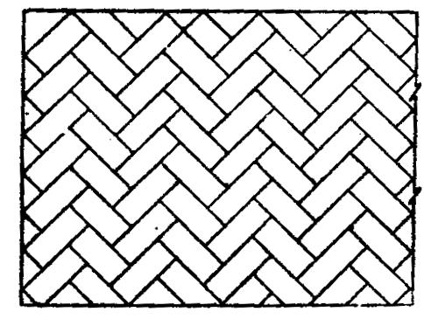
of stretchers between the facing and backing. Thus the raking course rectifies the defect of low longitudinal, stiffness in thick wall. This is of two types a. Herring bone bond (placed at 45⁰ in both direction) b. Diagonal bond as shown in fig 11.23.

Fig 11.23 Herring Bone Bond

Zigzag bond: This type of bond very much similar to herring bone bond. The only difference is that bricks are laid in zigzag way and used for paving the brick floor as shown in fig 11.24
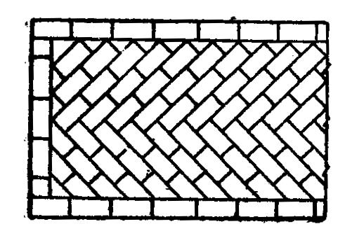

Fig 11.24 Zigzag Bond
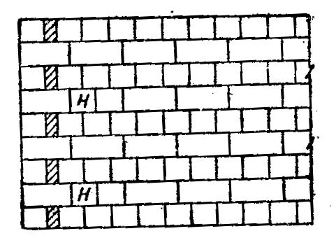
English cross bond: This type of bond is aesthetically more sound and posses greater strength than English bond. In this bond every alternate stretcher course has a header placed next to the quolin stretcher and rest of the details are similar to English bond as shown in fig 11.25

Fig 11.25 English Cross Bond

FLOORS

In order to sub-divide the portion between the plinth level or basement level and roof level, solid constructions are Carrie out. These constructions are known as floors and exposed top surface of floors are termed as floorings. Ground floors or basement floors, which directly rest on the ground, do not require the provision of a floor. But they are provided with suitable type of flooring.
PLINTH:
The portion of the wall between the ground level and the ground floor level is called plinth. It is usually of stone masonry. If the foundation is on piles, a plinth beam is cast to support wall above floor level. At the top of plinth a damp proof course is provided. It is usually 75 mm thick plain concrete course.
The function of the plinth is to keep the ground floor above ground level, free of dampness. Its height is not less than 450 mm. It is required that plinth level is at least 150 mm above the road level, so that connections to underground drainage system can be made.
FLOORING
Purpose of flooring is to get a good hard, level and beautiful surface for living. The floors directly resting on the ground are known as ground floors while the floors of each storey are known as upper floors.
Ground Floor
Apart from giving good finished surface, these floors should have good damp resistance. The ground surface is rammed well and a layer of red earth or sand is placed which is compacted. A layer of broken bricks, stones etc. is provided up to 150 mm below floor finish level and rammed. While ramming the surface is kept moist to get good compaction. Then 1 : 4 : 8 concrete of 100 to 150 mm thickness is provided as base course. Over this bed floor finish is laid.
The types of flooring used are:
1. Mud and moorum
2. Brick
3. Flag stone
4. Cement concrete
5. Terrazo
6. Mosaic
7. Marble
8. Tiles
9. Timber
10. Rubber
11. P.V.C.
1. Mud and Moorum Flooring: These floorings are used in low cost housing, specially in villages. Over the hard layer of earth filling mud or moorum layer is provided. The floor needs a thin wash of cow dung at least once a weak.
2. Brick Flooring: This is also a cheap floor construction. It is commonly used in godowns and factories. Bricks are laid flat or on edges. Bricks of good quality should be used for the construction. Brick layer is provided on sand bed or on lean concrete (1 : 8 : 16) bed. In both cases joints are rendered flush and finished with cement mortar.
3. Flag Stone Flooring: Laminated sand stones or slates of 20 mm to 40 mm thick in the form of slabs of 300 mm × 300 mm or 450 mm × 450 mm or in the form of rectangles of size 450 mm × 600 mm are used as floor finishes. The stone slabs are laid on 20 to 25 mm thick mortar spread over concrete bed. The joints are to be finished with rich mortar.
4. Cement Concrete Floors: It is modestly cheap and durable floor and hence commonly used in residential, commercial and industrial buildings. It consists of two courses-base course and wearing coat. Base course is laid over well compacted soil. Its thickness is usually 75 mm to 100 mm. It consists of lean cement concrete mix (1 : 4 : 8) or lime concrete containing 40% of 1 : 2 lime mortar and 60% of coarse aggregate of 40 mm size. After base coarse is hardened wearing coat of 40 mm is laid. It consists of panels of 1 m × 1 m, 2 m × 2 m or 1 m × 2 m. Alternate panels are laid with 1: 2: 4 concrete using wooden, glass or asbestos strip separators of 1.5 mm to 2.0 mm thickness. To get good bond between base coarse and wearing coat cement slurry wash is given before laying wearing coat panels. After 3–4 days of laying of one set of panel, another alternate panels are laid. Top of these panels are finished by tamping the surface with wooden floats and tapping with trowels, till cement slurry appears on top. It needs curing for 7 to 14 days. To get good appearance many times red-oxide finishing coat is provided.
5. Terrazo Flooring: Terrazo finishing coat is applied over concrete flooring to get pleasing appearance. Terrazo finish consists of 75 to 80% of surface marble chips embedded in cement mortar. Marble chips are mixed in cement in the proportion 1 : 1.25 to 1 : 2 and about 6 mm terrazzo topping is laid. The top is tamped and rolled. Additional marble chips are spread during tamping to get proper distribution of marble chips on the surface. After drying it for 12 to 20 hours, it is cured for 2–3 days.
Then grinding is made in the following three steps:
Ist grinding—Using coarse grade (No. 60) carborundum stones.
IInd grinding—Using medium grade (No. 120) carborundum stones.
IIIrd grinding—Using fine grade (No. 320) carborundum stones.
Plenty of water is used during grinding. After each grinding cement grout of cream-like consistency is applied and cured for 6–7 days. After final grinding and curing the floor is washed with plenty of water and then with dilute oxalic acid solution. Then floor is finished with polishing using machines and wax polish.
6. Mosaic Flooring: It consists of a finishing coat of small pieces of broken tiles of China glazed or of marble arranged in different patterns set in lime-surkhi or cement mortar. The base coarse is concrete flooring and on it 30 to 40 mm mortar layer is provided. On this mortar layer broken pieces of China glazed or marble are set to get different attractive patterns. After 20 to 24 hours of drying the top is rubbed with carborundum stone to get smooth and polished surface.
7. Marble Flooring: Marble slabs are cut to get marble tiles of 20 to 25 mm thickness. They are laid on floors similar to other tiles. With power driven machine surface is polished to get even and shining surface. This type of flooring is widely used in hospitals and temples.
8. Tiled Flooring: This is an alternative to terrazo flooring, used commonly used in residential, office and commercial buildings. Tiles of clay, cement or terrazo of standard sizes are manufactured in factories under controlled conditions. On the concrete base, 25 mm to 30 mm thick mortar is laid and these tiles are placed and pressed with trowel or wooden mallet. Before placing tiles care is taken to see that, neat cement slurry is applied to bottom side and sides of tiles to get good bond. Next day joints are cleaned of loose mortar and raked up to 5 mm depth. Then that is filled with coloured cement slurry to get uniform colour on the top surface. After curing for 7 days grinding and polishing is made as in the case of terrazo flooring.
9. Timber Flooring: Timber flooring are used in dancing halls and in auditoriums. Timber plates may be directly placed on concrete bed or may be provided over timber frame work. In latter case it is necessary to provide proper ventilation below the floor. This flooring is costly. 10. Rubber Flooring: Tiles or sheets of rubber with fillers such as cotton fibres, asbestos fibre or granulated cork are manufactured in variety of patterns and colours. These sheets or tiles may be fixed to concrete or timber floors. These floors are attractive and noise proof. However they are costly.
11. P.V.C. Flooring: Poly-Vinyl-Chloride (PVC) is a plastic which is available in different colour and shade. Nowadays tiles of this material are used widely. Adhesives are applied on concrete base as well as on bottom of PVC tiles. Then the tile is pressed gently with 5 kg wooden roller till the oozing of adhesive is seen. The oozed out adhesive is wiped and the floor is washed with warm soap water. The floor finish is smooth, attractive and can be easily cleaned. However it is slippery and costly.
DAMP PROOF AND FIRE PROOF CONSTRUCTION

Damp prevention and fire protection are the chief requirements to ensure the safety of buildings against dampness and fire respectively. The sources, effects, techniques and methods of damp prevention, materials used for damp-proofing (D.P.C) damp-proofing treatments in buildings, treatment of dampness are discussed under damp proof chapter.

14.1Sources of dampness(causes)

Dampness in building in generally due to one or more of the following causes

Faulty design of structure

Faulty construction or poor workmanship

Use of poor materials in construction

These cause give rise to an easy access to moisture to enter the building from different points, such as rising of moisture from ground, rain penetration through walls, roofs and floors etc. The moisture entering the building from foundation and roofs, travels in different directions further under the effects of capillary action and gravity respectively. The entry of water and its movements, in different parts of the building are positively due to the one or more of the causes listed above.

14.2 Effects of dampness:

1. The various effects caused due to dampness in buildings mainly results in poor functional performance, ugly appearance and structural weakness of the buildings.

2. A damp building creates unhealthy living and working conditions for the occupants

3. Presence of damp condition causes efflorescence on building surfaces which ultimately results in the disintegration of bricks stones, tiles etc and hence reduction of strength

4. It may result in softening and crumbling of plaster

5. It may cause bleaching and flaking of the paint which results in the formation of coloured patches on the wall surfaces and ceilings

6. It may result in the corrosion of metals used in the construction of buildings

7. The materials used as floor coverings such as tiles are damaged because they lose adhesion with the floor bases

8. Timber when in contact with damp condition, gets deteriorated due to the effect of warping, buckling and rolling of timber

9. All the electrical fittings gets deteriorated, causing leakage of electric current with the potential danger of a short circuit

10. Dampness promotes the growth of termites and hence creates unhygienic conditions in buildings
Dampness when accompanied by the warmth and darkness, breeds the germs of tuberculosis, neuralgia, aute and chronis neumatism etc which some times result in fatal diseases

14.3Techniques and methods of damp prevention:

The following are the precautions to be taken to prevent dampness in buildings, before applying the various techniques.

-The site should be located on high ground and well drained soil to safe guard against foundation dampness

-All the exposed walls should be of sufficient thickness to safeguard against rain protection (minimum 30cm)

-Bricks of superior quality free from defects should be used

-Good quality cement mortar (1:3) should be used to produce definite pattern and perfect bond in the building

-Cornices and string courses should be provided to through rain water away from the walls

-All the exposed surfaces like top of walls, compound walls etc should be covered with water proofing cement plaster

-Cavity walls are more reliable than solid walls in preventing the dampness

Techniques:

Use of damp proof courses

Water proof or damp proof treatments

Cavity walls or hallow walls

Guniting or shot concrete or shotcrete

Pressure grouting or cementation

Use of damp-proof courses (D.P.C.)

These are layers or membranes of water repellent materials such as bituminuous felts, mastic asphalt, plastic sheets, cement concrete, mortar, metal sheets, stones etc which are interposed in the building structure at all locations wherever water entry is anticipated or suspected.
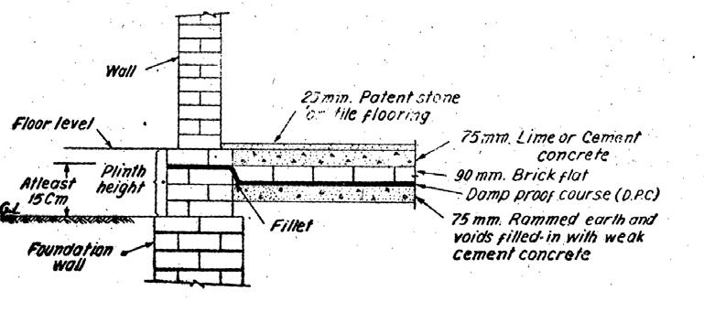

Fig 14.1 D.P.C. above ground level for new buildings
The best location or position of D.P.C. in the case of building without basement lies at plinth level or structures without any plinth level, it should be laid at least 15cm above ground level.The damp proof course provided horizontally and vertically in floors, walls etc. In the case of basements, laying of D.P.C. is known as taking Fig 14.1 shows the D.P.C. treatment above ground level.

Water proof surface treatments: The surface treatment consists in filing up the pores of the material exposed to moisture by providing a thin film of water repellent material over the surface (internal / external ) . External treatment is effective in preventing dampness

Many surface treatments, like pointing, plastering, painting, distempering etc are given to the exposed surfaces and also to the internal surface . The most commonly used treatment to protect the walls against dampness is lime cement plaster (1:6) (1-cement, 6-lime) mix proportion. Generally employed as water proofing agent in surface treatments are sodium or potassium silicate. Aluminium or zinc sulphate, Barium Hydroxide and magnesium sulphate in alternate applications. Soft soap and alum also in alternate applications, unie and unseed oil; coal tar, bitumen, waxes and fats; resins and gums Waxes and fats are not suitable in tropics as they melt with rise in temperatures.

Integral damp-proofing treatments :

The integral treatment consists of adding certain compounds to the concrete or mortar during the process of mixing, which when used in construction acts as barriers to moisture penetration under different principles

  - i) Compounds like chalk, talc, fallers earth etc have mechanical action principle (i.e.,) they fill the pores present in the concrete or mortar and make them dense and water proof
ii) Compounds like denser and water proof sulphates, calcium chlorides etc work on chemical action principle (i.e.) they react chemically and fill the pores to act as water-resistant
iii) The compounds like soaps, petroleum, oils fatty acids compounds such as sterates of calcium, sodium ammonium etc work on the repulsion principle i.e., they are used as admixture in concrete to react with it and become water repellent.
Cavity walls or hallow walls: A cavity wall consists of two parallel walls or leaves or skins of masonary separated by a continuous air space or cavity. The provision of continuous cavity in the wall per effectively prevent the transmission or percolation of dampness from outer walls or leaf to inner wall or leaf. The following are the advantages of cavity wall.

  - As there is no contact between outer and inner walls of cavity wall, possibility of moisture penetration is reduced to a minimum.

  - A cavity wall prevents the transmission of heat through wall.

  - A cavity wall offer good insulation against sound.

  - The cavity wall tends to reduce the nuisance of efflorescence.

  - The cavity wall also provides benefits such as economy, better comfort and hygienic conditions in buildings.The cavity wall construction and D.P.C. details for flat roofs is as shown in fig no 14.2
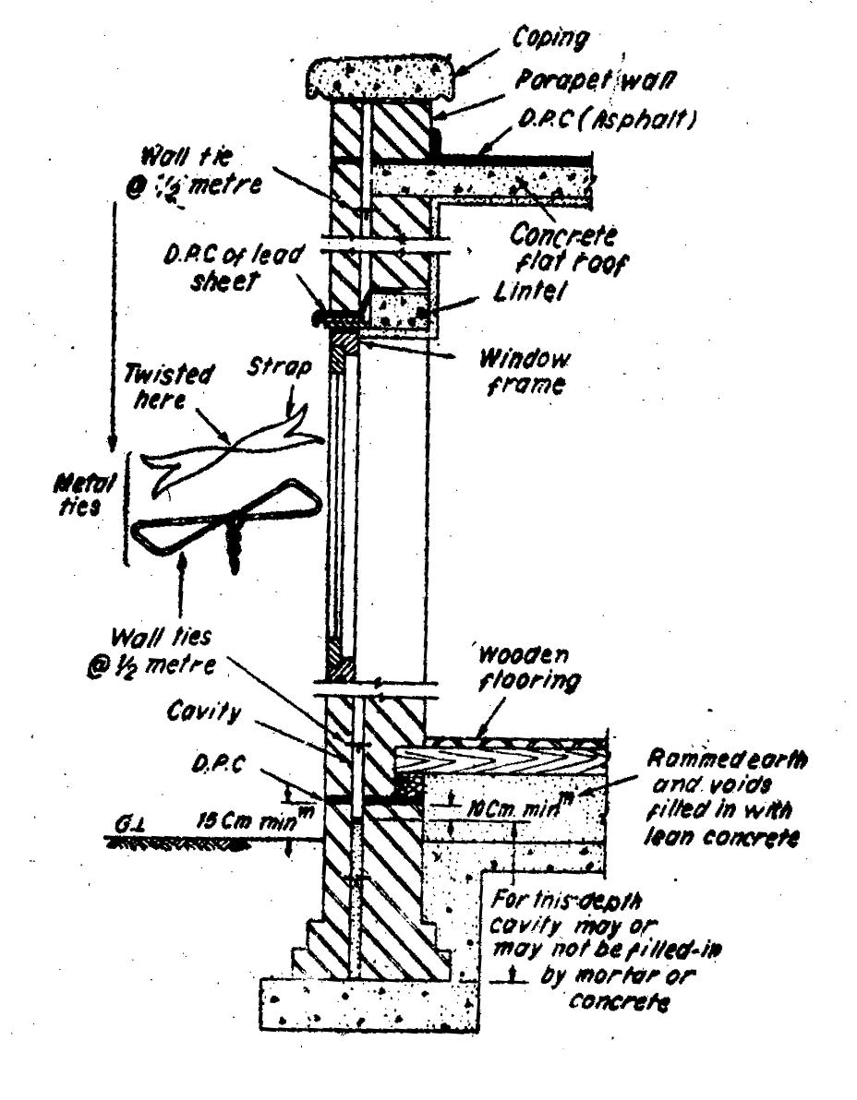

Fig 14.2 Cavity wall construction and D.P.C. details for flat roofs

Guniting: (or shot concrete) : The technique of guniting consists in forming an imperious layer of rich cement mortar (1:3) or fine aggregate mix for water proofing over the exposed concrete surface or over the pipes, cisterns etc for resisting the water pressure. By this technique, an impervious layer of high

compressive strength (600 to 700 kg/cm²) is obtained and hence this is also very useful for reconditioning or repairing old concrete works

Pressure grouting or (cementation). The mixture of cement, sand and water under pressure into the cracks, voids or fissures present in the structural component or the ground. In general, the foundations are given this treatment to avoid the moisture penetration. This technique also used for repairing structures, consolidating ground to improve bearing capacity, forming water cut-offs to prevent seepage etc.

